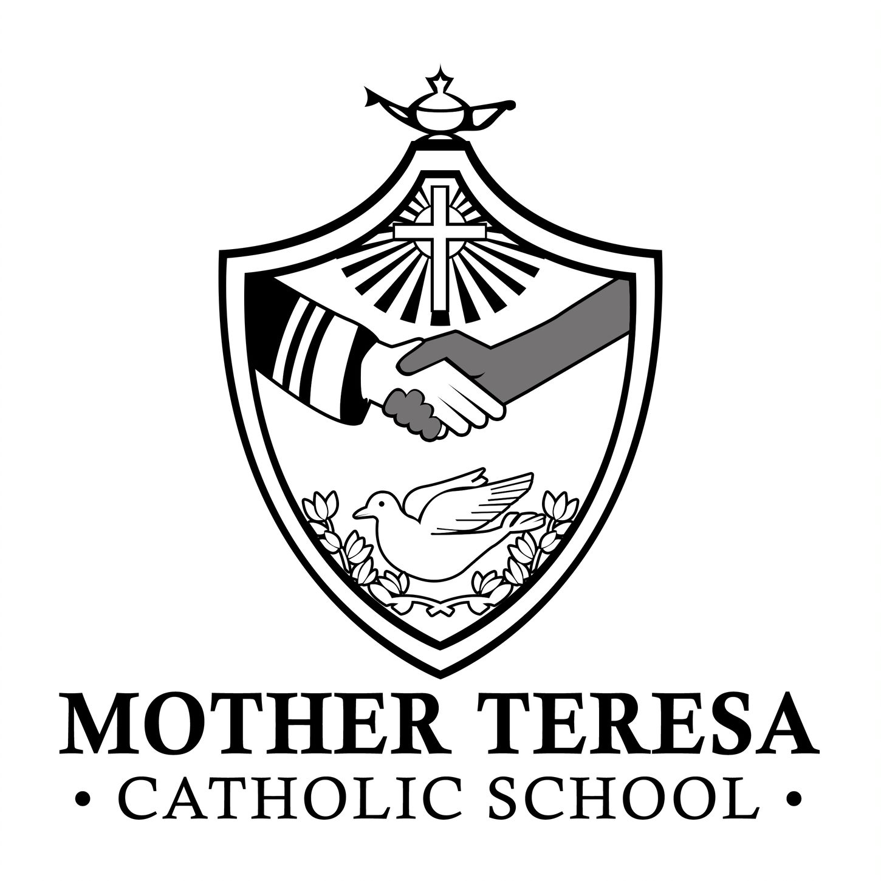

Wednesday, January 11, 2023
Dear Parents / Guardians,
I am writing to you on behalf of the Algonquin and Lakeshore Catholic District School Board to inform you of the initiation of the Kingston West Boundary Review consultation process.
As many of you are aware, the ALCDSB is currently constructing a brand-new school in the Woodhaven Subdivision on Holden Street, off Cataraqui Woods Drive. Prior to the completion of the construction and the opening of the school to students, the Board needs to establish the attendance boundaries for this school.
On December 13, 2022, the Board of Trustees authorized staff to conduct a School Attendance Boundary Review for the Kingston West review area, including French Immersion attendance boundaries for Our Lady of Mount Carmel Catholic School and Ecole Catholique Cathedrale, based upon an initial administrative boundary proposal as follows (and illustrated in the graphic below):
- The division of the existing Mother Teresa Catholic School boundary to reassign students residing north of Princess Street and west of Bayridge Drive within the Mother Teresa Catholic School boundary to the new school located at 386 Holden Street.
- The reassignment of French Immersion boundaries that coincide with the Regular Track attendance boundaries of Archbishop O’Sullivan Catholic School, Mother Teresa Catholic School, St. John XXIII Catholic School and St. Marguerite Bourgeoys Catholic School from Our Lady of Mount Carmel Catholic School to the new Kingston West Catholic Elementary School located at 386 Holden Street.
- The annexation of a small portion of the St. Marguerite Bourgeoys Catholic School boundary into the Our Lady of Lourdes Catholic School boundary to reduce enrolment pressures at St. Marguerite Bourgeoys Catholic School due to future possible development within the annexed area.
Proposed Kingston West Boundaries - Regular Track
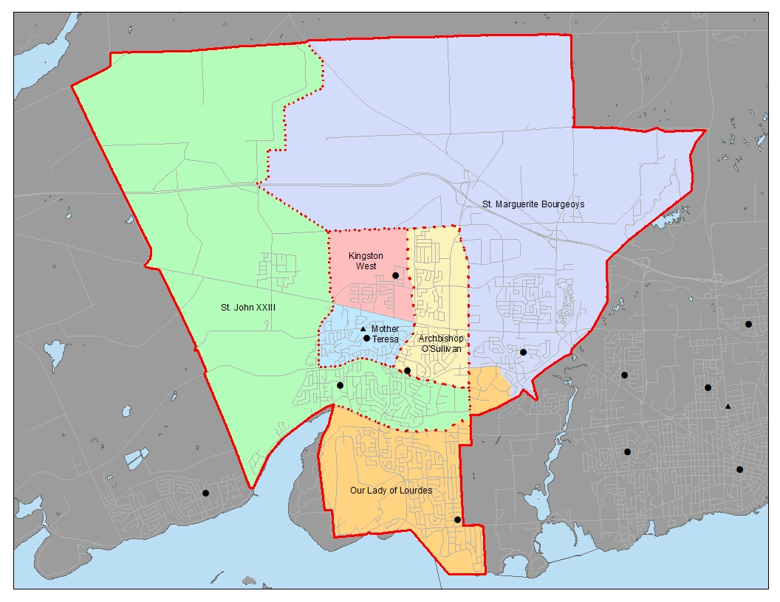

Proposed French Immersion Boundaries – Kingston Area
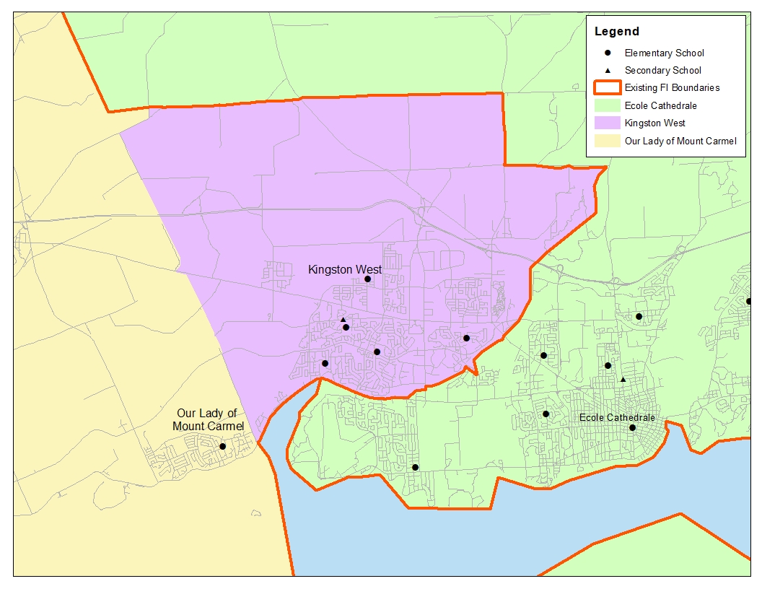
The Algonquin and Lakeshore Catholic District School Board is committed to an open and transparent process that allows for public input through a variety of means. A Public Meeting has been scheduled, as noted below, to present proposals under consideration and to offer our parents and guardians the opportunity to ask questions and provide input. The Board will compile and consider stakeholder input to bring to a future 2022-2023 Regular Board Meeting.
Public Meeting
Date | Time | Location
January 25, 2023 | 6:00 p.m. to 7:30 p.m. | Our Lady of Mount Carmel Catholic School (Gym)  97 Park Crescent, Amherstview
January 26, 2023 | 6:00 p.m. to 7:30 p.m. | Mother Teresa Catholic School  (Gym)  1044 Lancaster Drive, Kingston

We recognize that families may have many questions about this review, and additional information can be found on the Board’s website as it becomes available here.
Should you wish to provide comments or have any questions with respect to the boundary review, please feel free to submit them through this link:
Submit Kingston West Boundary Review Feedback
We are truly blessed to have this rare opportunity to welcome a new school to our Kingston West community and look forward to your continued support and cooperation as we navigate our way through this process.
Sincerely,

Stacey Porter
Principal
Mother Teresa Catholic School

Concetta Buragina
Vice Principal
Mother Teresa Catholic School

